The TRIALS of SPRING: Six short films. Nine women fighting for peace.
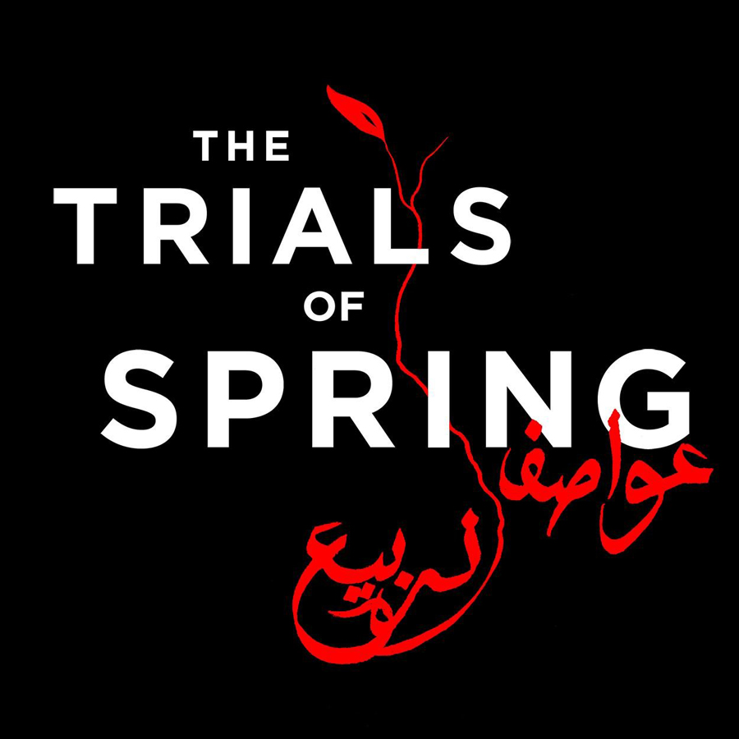
These films tell the story of women on the frontlines of the Arab Uprisings in their countries.
Produced by the New York Times, 2015

Tunisia: Keeping the Promise Length 4:58
Even before the revolution, Ghazala Mhamdi was leading the fight for jobs, freedom and human rights against the corrupt regime of President Zine El Abidine Ben Ali Ben Ali. Tunisia is now a fledgling democracy, and Ghazala, the veteran anti-government activist, is running for parliament.

Libya: Wake Up, Benghazi! Length 9:18
On June 25, 2014, Salwa Bugaighis was shot dead in her home by unknown militants, marking a new milestone in the country’s descent towards anarchy: the first female political assassination.

Egypt: Life’s Sentence Length 4:57
On December 17th, 2011, Hend Nafea, a young woman from a traditional, rural Egyptian family joined in a protest in central Cairo. Three years later, she was sentenced to life in prison for her participation on that day. In this piece – filmed a day after the sentencing, when emotions are still raw – Hend tells the story from her perspective. She maintains her innocence – and her pride, and grapples with the meaning of the sentencing for herself and her country.

Syria: Brides of Peace Length: 9:18
In the early days of Syria’s uprising, sisters Kinda and Lubna Zaour walked through the main souk in Damascus dressed as brides, a symbol of love, and carried banners calling for peace. They were arrested almost immediately. Upon their release, each sister became a bride once again under circumstances that also called for tremendous bravery: in the midst of a sectarian war and despite death threats from their extended family, both married outside of their religion.

Bahrain: Our Oath Length: 4:59
Tiny Bahrain was one of the few Gulf States to be swept up in the revolutionary fervor. But the government response was swift and brutal. Among those arrested in the crackdown were 50 medical professionals whose “crime” was helping injured protesters. Dr. Nada Dhaif was one of them. She was tortured in prison, and after her release, founded an organization that treats victims of torture and violence in Bahrain.

Yemen: When is the Time? Length: 5:42
Belquis Al Lahabi was a leading voice in Sanaa’s Change Square. In this conservative country -- dubbed the worst in the world for women -- the revolution offered feminists like Belquis a faint glimmer of hope. But as the country descends into war, women’s issues are being pushed to the side.

Take Action:
It’s Time to Reset the Peace Table:
https://youtu.be/d_fnmSe9X1M

Sign this petition at change.org
https://www.change.org/p/support-women-s-voices-in-countering-extremism

